FOUNDATIONS OF ARTIFICIAL INTELLIGENCE
PROJECT REPORT
AI-POWERED MAZE SOLVER: A VISUALIZER FOR SEARCH ALGORITHMS USING HILL CLIMBING AND SIMULATED ANNEALING
A PROJECT REPORT
Submitted by
2116240701508 – SHRI SARVENDRAN PS
2116240701469 – SANJAYRAM M

October, 2025

BONAFIDE CERTIFICATE
Certified that this project report “AI-POWERED MAZE SOLVER: A VISUALIZER FOR SEARCH ALGORITHMS USING HILL CLIMBING AND SIMULATED ANNEALING” is the bonafide work of “SHRI SARVENDRAN PS (2116240701508) and SANJAYRAM M (2116240701469)” who carried out the project work under my supervision.
………………………………………
SIGNATURE OF THE FACULTY INCHARGE
Submitted for the Practical Examination held on ____________________
………………………………………
SIGNATURE OF THE INTERNAL EXAMINER

ABSTRACT
Search algorithms form the foundation of Artificial Intelligence, yet their step-by-step behaviour is difficult to appreciate from pseudocode and theory alone. This project presents an AI-powered maze solver and visualiser that makes the behaviour of search algorithms observable. A randomly generated grid maze is modelled as a state-space problem in which the state is the agent's position, transitions occur through valid neighbouring cells and the goal is the exit cell. Two local-search algorithms, Hill Climbing and Simulated Annealing, are implemented in Python and guided by the Manhattan-distance heuristic; the same environment supplies reference results for BFS, DFS, Dijkstra and A*. A modular architecture comprising a user interface, maze manager, algorithm engine, visualizer engine and results analyzer animates each search in real time and records path, steps, cost and nodes visited. The results show that informed search examines far fewer cells than uninformed search, that Hill Climbing is fast but can be trapped by local optima, and that Simulated Annealing escapes them by probabilistically accepting worse moves. The tool offers an interactive, maze-focused learning experience for comparing algorithms side by side.

TABLE OF CONTENTS
CHAPTER NO. TITLE PAGE NO.
ABSTRACT ii
1 INTRODUCTION 1
1.1 BACKGROUND 1
1.2 PROBLEM STATEMENT 2
1.3 MOTIVATION 2
1.4 RESEARCH GAP 3
1.5 OBJECTIVES OF THE PROJECT 3
1.6 SCOPE AND LIMITATIONS 3
1.7 ORGANISATION OF THE REPORT 4
2 LITERATURE REVIEW 5
2.1 AI PROBLEM SOLVING AND SEARCH 5
2.2 LOCAL SEARCH AND OPTIMISATION 6
2.3 HILL CLIMBING 6
2.4 SIMULATED ANNEALING 7
2.5 MAZE REPRESENTATION, GENERATION AND SOLVING 8
2.6 EDUCATIONAL VISUALISATION OF ALGORITHMS 8
2.7 SUMMARY OF THE LITERATURE AND RESEARCH GAP 9
3 PROPOSED SYSTEM 10
3.1 ARCHITECTURE DIAGRAM 10
3.2 MAZE STATE FORMULATION 11
3.3 HEURISTIC FUNCTION 11
3.4 HILL CLIMBING ALGORITHM 12
3.5 SIMULATED ANNEALING ALGORITHM 13
3.6 COMPARISON OF HILL CLIMBING AND SIMULATED ANNEALING 15
3.7 REFERENCE ALGORITHMS AND COMPLEXITY 15
3.8 SYSTEM REQUIREMENTS 16
4 MODULES DESCRIPTION 17
4.1 MODULE 1: USER INTERFACE 17
4.2 MODULE 2: MAZE MANAGER 18
4.3 MODULE 3: ALGORITHM ENGINE 18
4.4 MODULE 4: VISUALIZER ENGINE 19
4.5 MODULE 5: RESULTS ANALYZER 20
4.6 MODULE INTERACTION 20
5 IMPLEMENTATION AND RESULTS 21
5.1 EXPERIMENTAL SETUP 21
5.2 RESULTS 23
6 CONCLUSION AND FUTURE WORK 28
6.1 CONCLUSION 28
6.2 LIMITATIONS 28
6.3 FUTURE WORK 29
7 REFERENCES 30

CHAPTER 1

INTRODUCTION

1.1 BACKGROUND
Artificial Intelligence (AI) is broadly concerned with building agents that perceive their environment and act so as to achieve their goals. A very large class of AI problems, including route planning, puzzle solving, game playing, robot navigation, scheduling and design optimisation, can be formulated as a search problem: the agent starts in an initial state and must find a sequence of actions that leads it to a goal state (Russell and Norvig, 2021). Search is therefore one of the foundational topics of any course on the Foundations of Artificial Intelligence.
Search algorithms are conventionally divided into two families. Systematic (global) search algorithms such as Breadth-First Search (BFS), Depth-First Search (DFS), Dijkstra's algorithm and A* keep track of the frontier of explored paths and are able to guarantee completeness and, in some cases, optimality. Local search algorithms such as Hill Climbing and Simulated Annealing, on the other hand, keep only a single current state and repeatedly move to a neighbouring state. They use very little memory and can operate on enormous or even continuous state spaces, but they pay for this efficiency by giving up the guarantees of completeness and optimality.
Although these ideas are elegant on paper, students meet them first as pseudocode, recurrence relations and complexity tables. The behaviour of an algorithm, that is, which state it visits next, why it turns back, and why it sometimes gets stuck, is dynamic and is difficult to appreciate from a static description. A maze is an ideal environment to make this behaviour visible. It is a small, discrete and easily drawn world with an unambiguous start, an unambiguous goal, walls that create dead ends, and a clear notion of progress toward the exit. Every step of a search can be drawn on the grid as it happens.
This project, the AI-Powered Maze Solver: A Visualizer for Search Algorithms, builds an interactive maze environment in Python in which two local-search algorithms, Hill Climbing and Simulated Annealing, are implemented, animated and compared on exactly the same maze. The system uses the Manhattan distance to the exit as its heuristic and reports quantitative metrics such as path length, number of steps, cost and nodes visited. It is also designed to be extendable, so that further algorithms can be plugged in without changing the rest of the application.

1.2 PROBLEM STATEMENT
The problem addressed by this project can be summarised in three observations drawn from the project proposal:
- Search algorithms are abstract in theory. Textbook descriptions express them through pseudocode and mathematical notation which hide their step-by-step dynamics.
- Students need to observe search behaviour. Understanding concepts such as greedy choice, local optima, plateaus, temperature and probabilistic acceptance requires seeing the algorithm at work, not merely reading about it.
- A maze environment provides an intuitive demonstration. A maze offers a familiar, visual and easily controlled problem in which the effect of each algorithmic decision is immediately visible.
Hence the central problem is: how can we design an interactive, maze-based software tool that implements and visualises local-search algorithms, allows their behaviour to be compared step by step on the same maze, and reports measurable performance metrics, so that the abstract theory of search becomes concrete and observable?

1.3 MOTIVATION
Several factors motivate the work. First, search is the entry point to nearly all of AI; a student who does not develop a firm intuition here will struggle with planning, constraint satisfaction, reinforcement learning and optimisation later on. Second, the failure modes of local search, being trapped in a local optimum or wandering on a plateau, are among the most instructive ideas in the subject, yet they are almost impossible to appreciate without watching a run unfold. Third, existing teaching aids usually demonstrate one algorithm in isolation, so learners cannot directly contrast a greedy method with a stochastic one on identical input. Finally, a maze solver is a compact project that touches the complete AI pipeline: problem formulation, heuristic design, algorithm implementation, visualisation and empirical evaluation.

1.4 RESEARCH GAP
A review of the literature and of available teaching tools (Chapter 2) reveals the following gap:
- Search algorithms are taught in isolation: each algorithm is introduced with its own example, so learners rarely see how different strategies behave on the same problem instance.
- Few tools visualise them side by side. Many visualisers concentrate on classical path-finding (BFS, DFS, A*) and ignore local-search methods such as Hill Climbing and Simulated Annealing, whose behaviour is stochastic and therefore harder to explain in words.
- Students need an interactive, maze-focused learning experience in which they can generate a maze, choose an algorithm, watch it run, and inspect the resulting metrics.

1.5 OBJECTIVES OF THE PROJECT
The research objectives of the project are:
- To visualise search behaviour in real time, showing explored cells, the current position and the final path on a maze grid.
- To implement two local-search algorithms, Hill Climbing and Simulated Annealing, using a common state representation and a common heuristic.
- To compare their behaviour on the same maze, so that differences in greediness, exploration, escape from local optima and solution quality can be observed directly.
- To build an educational maze game/tool that is interactive, lightweight and extendable, and that records metrics (path, steps, cost and nodes visited) for analysis.

1.6 SCOPE AND LIMITATIONS
The scope of the project is a two-dimensional, grid-based maze with walls, open cells, a single start cell and a single exit (goal) cell. Movement is restricted to the four cardinal directions (up, down, left and right), each with unit cost. The Algorithm Engine implements Hill Climbing and Simulated Annealing as the primary subjects of study, and the same environment is used to obtain reference results for the classical algorithms BFS, DFS, Dijkstra and A*.
The following are outside the scope of this work: three-dimensional or continuous environments, weighted terrain, multi-agent or dynamic (moving-wall) mazes, and learning-based methods such as reinforcement learning. Because Hill Climbing and Simulated Annealing are heuristic methods, no guarantee of optimality or completeness is claimed for them.

1.7 ORGANISATION OF THE REPORT
The remainder of the report is organised as follows. Chapter 2 reviews the literature on AI search, local search, Hill Climbing, Simulated Annealing and educational visualisation. Chapter 3 presents the proposed system, its architecture diagram, the formulation of the maze as a state space, the heuristic, and the two algorithm flows. Chapter 4 describes each software module in detail. Chapter 5 explains the implementation, the experimental set-up and the results. Chapter 6 concludes the report and outlines future work, and Chapter 7 lists the references.

CHAPTER 2

LITERATURE REVIEW
This chapter surveys the four areas on which the project rests, corresponding to the literature survey of the proposal: (i) AI problem solving and search, (ii) local search and optimisation, (iii) Hill Climbing and Simulated Annealing, and (iv) educational visualisation. The chapter closes by identifying the research gap that the present work fills.

2.1 AI PROBLEM SOLVING AND SEARCH
The formal treatment of problem solving as search is described comprehensively by Russell and Norvig (2021). A search problem is defined by an initial state, a set of actions available in each state, a transition model that gives the result of an action, a goal test and a path cost. The set of all reachable states forms the state space, which may be viewed as a graph whose nodes are states and whose edges are actions. Solving the problem means finding a path in this graph from the initial state to a goal state.
Uninformed search strategies use no knowledge about the problem other than its definition. Breadth-First Search expands the shallowest node first; it is complete and, when all step costs are equal, returns a shortest path, but it must hold an entire frontier in memory. Depth-First Search follows a single branch to its end before backtracking; it needs memory proportional only to the depth but is neither optimal nor guaranteed to terminate in graphs with cycles unless visited states are recorded (Korf, 1985). Dijkstra (1959) introduced the uniform-cost method of expanding the node with the lowest path cost so far, which yields optimal paths for graphs with non-negative edge costs.
Informed (heuristic) search exploits domain knowledge in the form of a heuristic function h(n) that estimates the remaining cost from node n to a goal. Pearl (1984) gives the foundational account of heuristics. The best-known informed algorithm, A*, was introduced by Hart, Nilsson and Raphael (1968); it expands the node with the smallest value of f(n) = g(n) + h(n), where g(n) is the cost accumulated so far. If h never overestimates the true remaining cost (it is admissible) and satisfies the triangle inequality (it is consistent), A* is optimal, and Dechter and Pearl (1985) proved that it is optimally efficient among algorithms using the same heuristic information.
On a four-connected grid maze the Manhattan distance |x₁ − x₂| + |y₁ − y₂| is the standard heuristic. Since each move changes exactly one coordinate by one unit, no path can be shorter than the Manhattan distance, which makes the heuristic both admissible and consistent. Its cheap computation and its natural fit to grid geometry explain its choice in this project.

2.2 LOCAL SEARCH AND OPTIMISATION
Systematic search becomes impractical when the state space is astronomically large, or when the path to the goal is irrelevant and only the final configuration matters. Local search algorithms operate on this kind of problem. They maintain a small number of current states (often just one), generate neighbouring states, and move to a neighbour according to some rule; they do not keep a search tree or a frontier. Two advantages follow: they use a constant amount of memory, and they can often find reasonable solutions in enormous or continuous spaces where systematic algorithms cannot (Russell and Norvig, 2021).
Local search is usually explained through the state-space landscape, in which each state has a location and an elevation given by the objective function. The aim is to find the global maximum (or, equivalently, the global minimum of a cost function). Landscapes contain local optima, states better than all their neighbours yet worse than the global optimum; plateaus, flat regions in which neighbours have equal value; and ridges, sequences of local optima that are hard to traverse with single-step moves. These features are precisely what make local search algorithms interesting to compare and are what the visualiser of this project is meant to expose.
In a maze, the landscape is defined by the heuristic: the value of a cell is its Manhattan distance to the exit. Because walls block movement, the landscape is riddled with local minima; a cell at the bottom of a dead-end corridor that points toward the exit is closer to the goal than any of its accessible neighbours, yet is not the goal. The maze thus provides a naturally rugged landscape on which the strengths and weaknesses of local search show up clearly.

2.3 HILL CLIMBING
Hill Climbing is the simplest local search method. Beginning with an initial state, it repeatedly examines the neighbouring states and moves to the one with the best objective value, terminating when no neighbour improves on the current state. It is often described as “like climbing Everest in thick fog with amnesia”: the agent sees only its immediate surroundings and remembers nothing else. Several variants exist:
- Steepest-ascent (best-improvement) Hill Climbing examines all neighbours and selects the best. This is the version used in this project.
- Simple (first-choice) Hill Climbing accepts the first neighbour that improves on the current state.
- Stochastic Hill Climbing chooses at random among the improving moves, with probability depending on the steepness of the improvement.
- Random-restart Hill Climbing repeatedly starts fresh climbs from random initial states and keeps the best result, converting an incomplete algorithm into one that is complete with probability approaching one.
Hill Climbing is fast and memory-frugal, but it has well-documented limitations: it halts at local optima, it may wander or stop on plateaus, and it cannot follow ridges. In a maze these correspond to walking into a dead end whose closing wall is nearer the exit (in Manhattan terms) than any exit from the dead end. The algorithm has no mechanism to retreat, since retreating would mean accepting a worse state.

2.4 SIMULATED ANNEALING
Simulated Annealing (SA) addresses the weakness of Hill Climbing by occasionally allowing moves that make the objective worse. It is inspired by annealing in metallurgy, in which a material is heated and then cooled slowly so that it settles into a low-energy crystalline state. The statistical basis was laid by Metropolis et al. (1953), who described how to simulate a collection of atoms in equilibrium at a given temperature. Kirkpatrick, Gelatt and Vecchi (1983) and, independently, Černý (1985) recognised that the same procedure could be applied to combinatorial optimisation, and demonstrated it on problems such as circuit placement and the travelling-salesman problem.
At each iteration, SA selects a random neighbour and computes the change in cost Δ = cost(new) − cost(current). If Δ < 0 the move is always accepted; otherwise it is accepted with probability e^(−Δ/T), where T is the current temperature (the Metropolis criterion). The temperature is reduced according to a cooling schedule, commonly geometric, T ← αT with 0 < α < 1. At high T almost every move is accepted and the search explores widely; as T falls, the algorithm becomes increasingly selective and at T ≈ 0 it degenerates into Hill Climbing. With a sufficiently slow cooling schedule, SA converges to a global optimum with probability one, although the required schedule is impractically slow in the worst case. Johnson et al. (1989) present an extensive experimental evaluation showing the practical influence of the schedule parameters.
The comparison between Hill Climbing and Simulated Annealing is therefore a comparison between a purely greedy and a controlled-randomness strategy. A maze that traps Hill Climbing in a dead end often does not trap Simulated Annealing, which can climb out by accepting a few “bad” steps while the temperature is still high. The project is designed to display exactly this contrast.

2.5 MAZE REPRESENTATION, GENERATION AND SOLVING
Mazes are commonly modelled as grids in which each cell is either open or blocked, or as graphs in which cells are nodes and passages are edges. A “perfect” maze contains exactly one path between any two cells and can be generated by algorithms such as recursive backtracking, randomised Kruskal, randomised Prim or Wilson's algorithm (Buck, 2015). Solving techniques include wall-following, flood fill, and the general graph-search algorithms discussed above. Grid mazes are a favourite benchmark for path-finding because they are simple to construct and their solutions are simple to verify (Cormen et al., 2022).

2.6 EDUCATIONAL VISUALISATION OF ALGORITHMS
Algorithm visualisation has been an active research area in computer-science education for decades. Hundhausen, Douglas and Stasko (2002) reviewed 24 experimental studies and concluded that what matters is not how much information a visualisation shows, but how actively the learner is engaged with it: predicting the next step, changing inputs, or constructing their own visualisation improved learning significantly more than passive viewing. Naps et al. (2002) reached similar conclusions in a working-group report, proposing an engagement taxonomy (no viewing, viewing, responding, changing, constructing and presenting). Shaffer et al. (2010) surveyed the state of the field and found that many available visualisations are of poor quality or poorly integrated into teaching, and recommended interactivity, appropriate pacing and integration with course content.
These findings directly inform the design of this project: the tool lets the student choose the algorithm, generate new mazes, watch the search unfold step by step, and examine numerical results afterwards, thereby supporting the “viewing”, “changing” and “responding” levels of engagement.

2.7 SUMMARY OF THE LITERATURE AND RESEARCH GAP
Table 2.1 Summary of the surveyed literature and its relevance to the project
Area | Key contribution | Relevance to this project
AI problem solving and search | State-space formulation; uninformed and informed search; A* optimality (Hart et al., 1968; Russell and Norvig, 2021) | Maze formulated as a state-space problem; classical algorithms used as reference
Local search and optimisation | Landscape view; local optima, plateaus and ridges (Russell and Norvig, 2021) | Maze heuristic landscape contains many local minima
Hill Climbing | Greedy best-neighbour move; variants such as random restart | Greedy baseline algorithm in the Algorithm Engine
Simulated Annealing | Metropolis criterion and cooling schedule (Metropolis et al., 1953; Kirkpatrick et al., 1983) | Stochastic algorithm capable of escaping local optima
Educational visualisation | Engagement is key to learning from visualisations (Hundhausen et al., 2002; Naps et al., 2002) | Interactive maze game with step-by-step visualisation

Although each of the above areas is well studied, the literature reveals that (a) search algorithms are usually taught and demonstrated in isolation, (b) side-by-side visual comparison of local-search algorithms is uncommon, and (c) learners lack an interactive, maze-focused environment for exploring these ideas. The present project is designed to fill this gap.

CHAPTER 3

PROPOSED SYSTEM

3.1 ARCHITECTURE DIAGRAM
The proposed system is organised as a pipeline of five loosely coupled modules, shown in Figure 3.1. The user drives the system through the User Interface; the Maze Manager creates and stores the maze; the Algorithm Engine runs the selected search algorithm (Hill Climbing or Simulated Annealing, with room for further algorithms); the Visualizer Engine renders the search in real time; and the Results Analyzer collects and reports the metrics of the run. The Maze State and the Heuristic underpin the Algorithm Engine and are described in Sections 3.2 and 3.3.
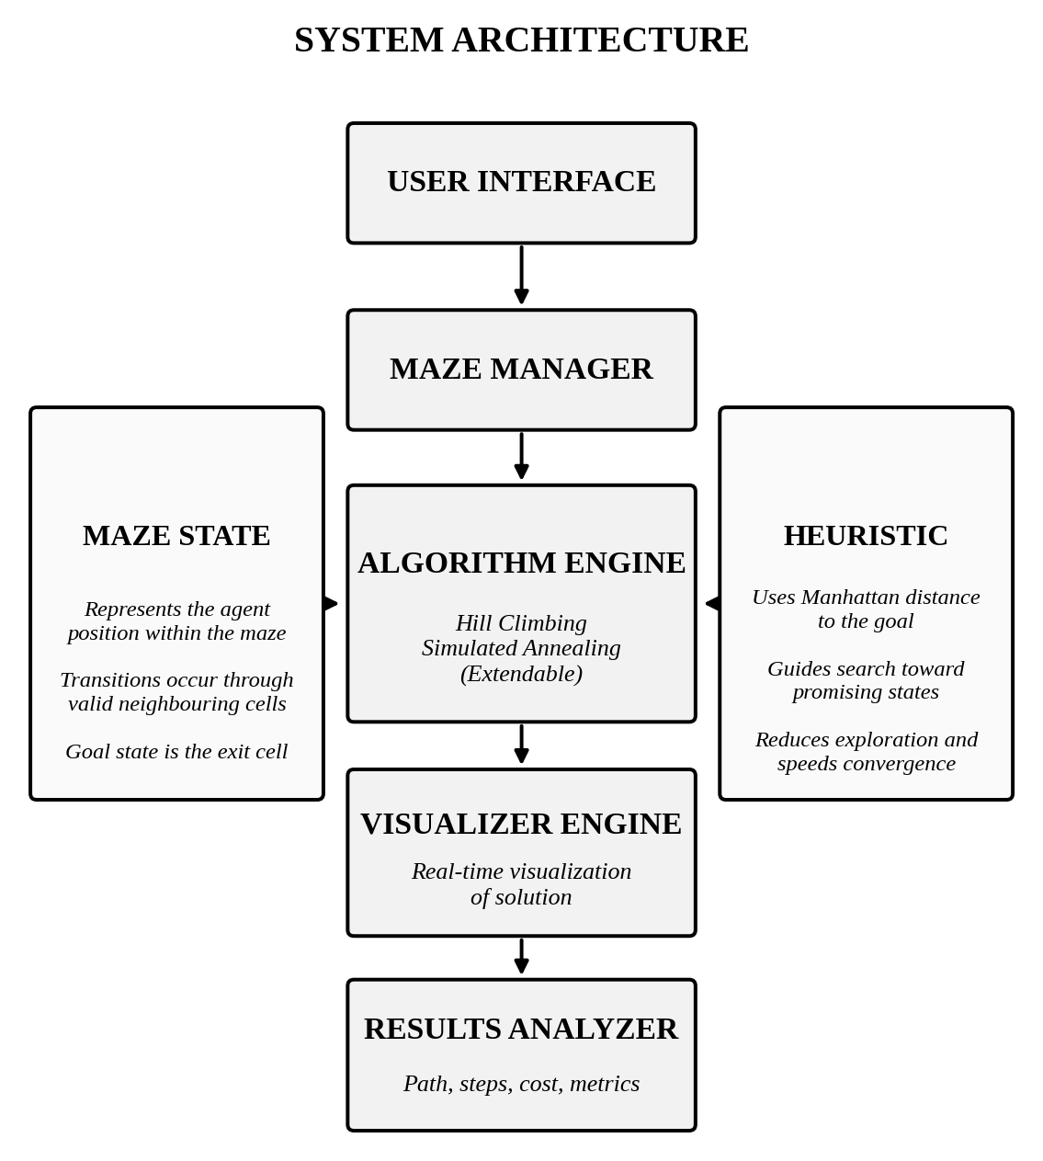
Figure 3.1 System architecture of the AI-powered maze solver
The separation of concerns in this architecture has practical benefits. The algorithms know nothing about drawing, so new algorithms can be added to the Algorithm Engine without touching the Visualizer Engine; a different maze generator can be substituted in the Maze Manager without touching the algorithms; and the Results Analyzer receives the same kind of record from every algorithm, so comparisons are always like-for-like.

3.2 MAZE STATE FORMULATION
The maze problem is formulated as a search problem with the following components:
Table 3.1 Formulation of the maze as a search problem
Component | Definition in this project
State | The agent position (row, column) on the grid. The state “represents the agent position within the maze”.
Initial state | The start cell of the maze (top-left in the default layout).
Actions | Move up, down, left or right into an adjacent cell.
Transition model | A move is valid only if the target cell lies inside the grid and is not a wall. Transitions therefore occur through valid neighbouring cells.
Goal test | The current cell equals the exit cell (bottom-right in the default layout).
Path cost | Each move costs 1; the cost of a path equals the number of moves.

A state also carries book-keeping information used by the algorithms and the Results Analyzer: the accumulated cost g, the heuristic value h and a pointer to the parent state, so that the final path can be reconstructed by following parent pointers from the goal back to the start.

3.3 HEURISTIC FUNCTION
Both algorithms are guided by the Manhattan distance to the goal. For a cell a = (r₁, c₁) and the goal b = (r₂, c₂),
h(a) = |r₁ − r₂| + |c₁ − c₂|
The heuristic has three useful properties in this project. It guides the search toward promising states, because cells that are closer to the exit in grid terms receive lower values. It reduces exploration and speeds convergence, since the search does not need to expand cells that lead away from the goal. And it is admissible and consistent on a four-connected unit-cost grid, so the same function can be used unchanged with A* when a reference optimal solution is required. It is, however, blind to walls, which is precisely why it produces local optima in a maze and why the maze is such a good demonstration environment for local search.

3.4 HILL CLIMBING ALGORITHM
The Hill Climbing implementation follows the flow shown in Figure 3.2. The search starts at the start cell; at each iteration it evaluates all valid neighbouring cells, moves to the neighbour with the lowest heuristic value, and repeats until either the goal is reached or no neighbour improves on the current cell, in which case the algorithm has reached a local optimum (or plateau) and returns the best solution found so far.
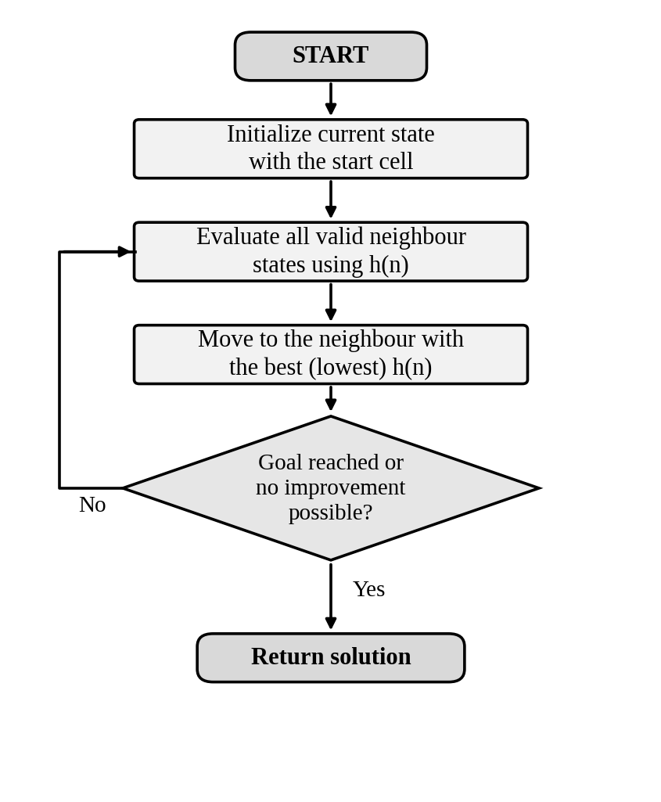
Figure 3.2 Flow of the Hill Climbing algorithm
Algorithm 1: Hill Climbing (steepest descent on h)
current <- start
while true:
if current == goal: return SUCCESS(path)
N <- valid neighbours of current
best <- argmin over n in N of h(n)
if h(best) >= h(current): return STUCK(path) # local optimum
current <- best; append current to path

Hill Climbing is deterministic for a given maze and start cell, uses O(1) additional memory apart from the path being recorded, and performs at most one evaluation of each neighbour per step, i.e. O(b) work per iteration with b ≤ 4. Its weakness is that success depends entirely on the shape of the maze: in a maze whose corridors continue to reduce the Manhattan distance, it reaches the exit almost directly, but a dead end that faces the exit halts it permanently.

3.5 SIMULATED ANNEALING ALGORITHM
Simulated Annealing follows the flow shown in Figure 3.3. It initialises the current state and a starting temperature, then repeatedly (i) generates a random neighbour, (ii) computes the cost difference Δ between the neighbour and the current state, (iii) accepts the move if it improves the cost or, otherwise, with probability e^(−Δ/T), and (iv) lowers the temperature. The search ends when the goal is reached or the temperature has fallen below a threshold.
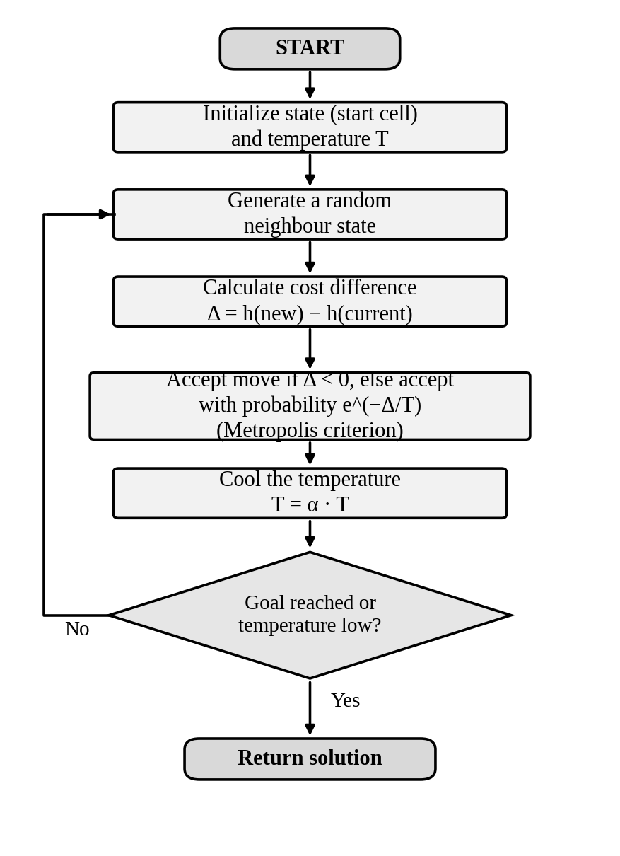
Figure 3.3 Flow of the Simulated Annealing algorithm
Algorithm 2: Simulated Annealing
current <- start; T <- T0
while T > T_min and current != goal:
n <- random valid neighbour of current
delta <- h(n) - h(current)
if delta < 0 or random() < exp(-delta / T):
current <- n; append current to path
T <- alpha * T # geometric cooling
return path, (current == goal)

The role of the temperature is easiest to see numerically. Table 3.2 shows the probability of accepting a move that worsens the heuristic by Δ = 1 (one step farther from the exit) at several temperatures.
Table 3.2 Probability of accepting a worsening move (Δ = 1) at different temperatures
Temperature T | e^(−Δ/T) | Behaviour
10 | 0.905 | Almost every move accepted; wide exploration
1 | 0.368 | Worsening moves accepted about one time in three
0.1 | 0.000045 | Worsening moves practically never accepted; behaves like Hill Climbing

Because the cost difference is computed from the Manhattan heuristic, a step that moves one cell away from the exit has Δ = +1, while a step toward the exit has Δ = −1. Early in the run the walker can therefore back out of a dead end; later, as T falls, it commits to whichever corridor it has found.

3.6 COMPARISON OF HILL CLIMBING AND SIMULATED ANNEALING
Table 3.3 Hill Climbing versus Simulated Annealing on the maze
Aspect | Hill Climbing | Simulated Annealing
Move selection | Best neighbour (greedy) | Random neighbour, accepted by Metropolis criterion
Worsening moves | Never accepted | Accepted with probability e^(−Δ/T)
Determinism | Deterministic | Stochastic; runs may differ
Local optima | Gets trapped in dead ends | Can escape while T is high
Control parameters | None | Initial temperature, cooling rate, stopping temperature
Memory | O(1) besides the path | O(1) besides the path
Typical path | Direct, when it succeeds | May wander before converging
Completeness / optimality | Not guaranteed | Not guaranteed in finite time

3.7 REFERENCE ALGORITHMS AND COMPLEXITY
To place the two local-search algorithms in context, the same environment is also used to obtain results for four classical systematic algorithms. Table 3.4 summarises their theoretical properties on a grid with V cells and E adjacencies, branching factor b, and maximum depth m.
Table 3.4 Theoretical properties of the algorithms considered
Algorithm | Complete | Optimal | Time | Space
BFS | Yes | Yes (unit cost) | O(V + E) | O(V)
DFS | Yes (with visited set) | No | O(V + E) | O(V)
Dijkstra | Yes | Yes | O((V + E) log V) | O(V)
A* (Manhattan) | Yes | Yes (admissible h) | Depends on h; ≤ Dijkstra | O(V)
Hill Climbing | No | No | O(b · path length) | O(1)
Simulated Annealing | No (probabilistic) | No | O(number of iterations) | O(1)

3.8 SYSTEM REQUIREMENTS

3.8.1 Functional requirements
- Generate a random maze layout with a start and an exit cell.
- Allow the user to select the algorithm to be run (Hill Climbing or Simulated Annealing).
- Animate the search step by step, showing the current cell, the visited cells and the final path.
- Compute and display the metrics: path, steps, cost and nodes visited.
- Allow the same maze to be re-run with a different algorithm for comparison.

3.8.2 Non-functional requirements
- Lightweight: the tool runs smoothly on an ordinary computer and keeps the visualisation interactive.
- Extendable: the Algorithm Engine must allow new algorithms to be added with minimal change.
- Usable: the interface must be intuitive for students with no prior experience of the tool.
- Correct: the reported metrics must be consistent with what is drawn on the grid.

CHAPTER 4

MODULES DESCRIPTION
The system consists of five modules that correspond to the blocks of the architecture diagram (Figure 3.1). This chapter describes the purpose, inputs, processing and outputs of each module. Figure 4.1 shows how data flows between them during a single run.
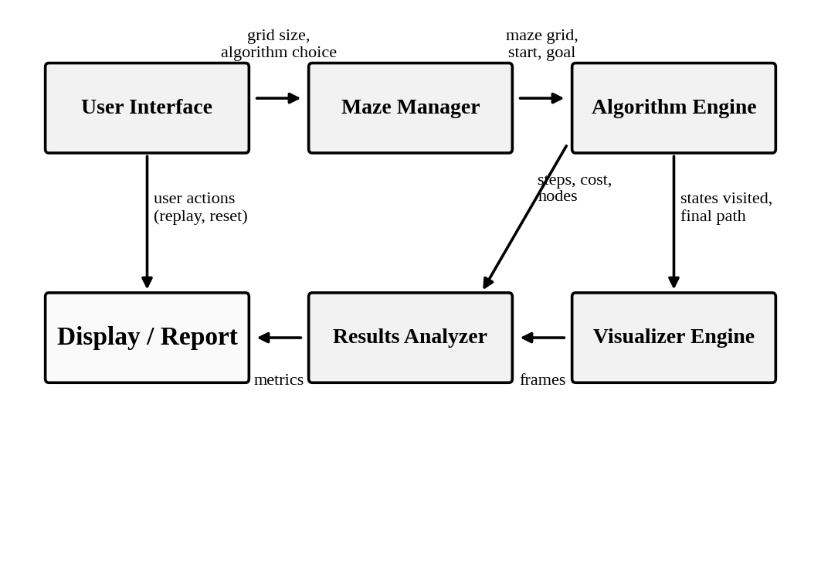
Figure 4.1 Data flow between the modules of the system

4.1 MODULE 1: USER INTERFACE
The User Interface is the entry point of the application and the only module the learner interacts with directly. It presents the maze and a set of controls and translates the user's actions into requests to the other modules.
- Inputs: user actions such as generating a new maze, selecting Hill Climbing or Simulated Annealing, starting, pausing, resetting or replaying a run, and (for Simulated Annealing) adjusting parameters.
- Processing: validates the requests, forwards the chosen algorithm and maze to the Algorithm Engine, and passes on display preferences to the Visualizer Engine.
- Outputs: the interactive window in which the maze, the animation and the metrics are displayed.
Because the interface is what makes the tool an “educational maze game” rather than a batch program, it is designed to keep the learner in control: the same maze can be replayed with a different algorithm, and each run can be observed step by step before the summary metrics are shown.

4.2 MODULE 2: MAZE MANAGER
The Maze Manager is responsible for creating, storing and answering queries about the maze environment.

4.2.1 Maze representation
The maze is stored as a two-dimensional grid. Each cell holds one of four symbolic values: an open cell, a wall, the start cell or the goal (exit) cell. This representation makes the neighbour test trivial (a cell index lookup), makes drawing straightforward (one square per cell) and makes the memory footprint proportional to the number of cells.

4.2.2 Maze generation
A new, randomly generated maze is produced each time the user requests one (the “Maze Generation” output of Section 5.2). A generator such as recursive backtracking, which carves passages through a grid of walls, guarantees that a path from the start to the exit exists, so that every generated maze is solvable in principle (Buck, 2015). The start is placed in one corner and the exit in the opposite corner to make the search non-trivial.

4.2.3 Neighbour service
The module provides the function that returns the valid neighbours of a cell: the up to four adjacent cells that lie within the grid and are not walls. This function defines the transition model of the problem and is shared by all algorithms, which guarantees that every algorithm is solving exactly the same problem.

4.3 MODULE 3: ALGORITHM ENGINE
The Algorithm Engine is the core of the system. It receives the maze and the identity of the algorithm from the earlier modules, executes the search, and produces a record of the run consisting of the ordered list of visited states, the final path, the number of steps and the cost. Each algorithm implements the same interface, which is what makes the engine extendable: adding an algorithm means writing one new function that accepts a maze and returns a run record.

4.3.1 Hill Climbing component
This component implements steepest-descent Hill Climbing on the Manhattan-distance heuristic exactly as in Algorithm 1. At each step it queries the neighbour service, evaluates h for every neighbour, and moves to the best one. It reports one of two outcomes: “goal reached” or “no improvement” (a local optimum or plateau was hit). The latter outcome is not treated as a program error; it is a legitimate and instructive result that the Visualizer Engine highlights.

4.3.2 Simulated Annealing component
This component implements Algorithm 2. It maintains the current state, the temperature T, the cooling rate α and the stopping temperature. At each iteration it selects a random valid neighbour, computes Δ, applies the Metropolis criterion using a random number, and cools T geometrically. The component records every state it moves through so that the animation shows how the search wanders and recovers. Because it is stochastic, two runs on the same maze can differ; the replay facility of the interface therefore doubles as a demonstration of randomness.

4.3.3 Extension point for further algorithms
The proposal deliberately marks the Algorithm Engine as “extendable”. Classical algorithms such as BFS, DFS, Dijkstra and A* are provided through the same interface and are used to obtain the reference figures of Section 5.2. Other local-search variants, such as random-restart Hill Climbing or stochastic Hill Climbing, can be added in the same way.

4.4 MODULE 4: VISUALIZER ENGINE
The Visualizer Engine converts the run record produced by the Algorithm Engine into a real-time visualisation of the solution. Its responsibilities are:
- to draw the maze grid with distinct colours for walls, open cells, the start and the exit;
- to animate the search by highlighting the cells as they are visited, so that the order and extent of exploration are visible (“Visited Cells”);
- to draw the final path from the start to the exit (“Solved Path”); and
- to indicate when a run ends without reaching the exit, for example when Hill Climbing halts at a local optimum.
The engine controls the animation speed so that each step is long enough to follow. Since it only reads the run record and never modifies the maze, it cannot influence the outcome of an algorithm; this separation ensures that what is drawn is faithful to what the algorithm actually did.

4.5 MODULE 5: RESULTS ANALYZER
The Results Analyzer collects quantitative information about every run and presents it in a uniform form so that algorithms can be compared. The following metrics are captured for each algorithm:
Table 4.1 Metrics recorded by the Results Analyzer
Metric | Meaning | Why it matters
Path | The ordered list of cells from start to exit | Verifies correctness and lets the path be drawn
Path length / steps | Number of moves in the final path (and in the whole run) | Measures solution quality and effort
Cost | Sum of move costs (1 per move) | Objective value of the solution
Nodes visited | Distinct cells examined during the search | Measures search effort and exploration
Execution time | Wall-clock time of the run | Shows practical speed
Memory used | Approximate memory consumed by the algorithm | Contrasts O(1) local search with O(V) systematic search

The analyzer's output feeds the “Algorithm Comparison” panel of the interface and the comparative tables of Chapter 5.

4.6 MODULE INTERACTION
A complete session proceeds as follows. (1) The user requests a maze and selects an algorithm in the User Interface. (2) The Maze Manager builds the grid and fixes the start and the goal. (3) The Algorithm Engine runs the chosen algorithm on that grid using the shared neighbour service and heuristic. (4) The Visualizer Engine animates the recorded states and path. (5) The Results Analyzer computes and displays the metrics. (6) The user may then choose another algorithm and re-run it on the same maze, returning to step (3). Because all modules communicate through simple data records, each can be developed and tested independently.

CHAPTER 5

IMPLEMENTATION AND RESULTS

5.1 EXPERIMENTAL SETUP

5.1.1 Programming language and tools
The system is implemented in Python, using the core libraries of the language for efficient algorithm execution and visualisation. Python was chosen because its concise syntax keeps the algorithm code close to the pseudocode taught in class, which is helpful for an educational tool; because its standard library supplies the required data structures (lists, sets, dictionaries, queues and heaps), random-number generation, mathematics and timing; and because graphical toolkits for drawing a grid and animating it are readily available.

5.1.2 Maze and grid representation
The maze is represented as a two-dimensional grid structure with walls, open cells, and the start and goal states. Rows and columns are indexed from zero at the top-left corner. A position is a (row, column) pair, and the four possible moves are the offsets (−1, 0), (1, 0), (0, −1) and (0, 1).

5.1.3 Heuristic and search states
Each search state tracks its position, cost and parent, which is used both to guide the search and to reconstruct the path once the goal has been reached. Listing 5.1 shows the state class together with the Manhattan-distance heuristic, the neighbour generator and the path-reconstruction routine.
class Node:
def __init__(self, pos, g, h, parent=None):
self.pos = pos # (row, col) of the agent
self.g = g # cost accumulated so far
self.h = h # heuristic estimate to the goal
self.parent = parent # previous node on the path
self.f = g + h

def heuristic(a, b): # Manhattan distance
return abs(a[0] - b[0]) + abs(a[1] - b[1])

def neighbors(node, grid):
for n in valid_moves(node.pos, grid):
yield n

def reconstruct(node):
path = []
while node:
path.append(node.pos)
node = node.parent
return path[::-1] # start -> goal
Listing 5.1 State representation, heuristic and path reconstruction
Listing 5.2 gives the core of the two local-search algorithms in Python. They correspond line by line to Algorithms 1 and 2 of Chapter 3.
import math, random

def hill_climbing(grid, start, goal, max_steps=10000):
current, path = start, [start]
for _ in range(max_steps):
if current == goal:
return path, True
best = min(valid_moves(current, grid),
key=lambda n: heuristic(n, goal))
if heuristic(best, goal) >= heuristic(current, goal):
return path, False # local optimum / plateau
current = best
path.append(current)
return path, False

def simulated_annealing(grid, start, goal,
T0=100.0, alpha=0.995, T_min=1e-3):
current, path, T = start, [start], T0
while T > T_min and current != goal:
nxt = random.choice(list(valid_moves(current, grid)))
delta = heuristic(nxt, goal) - heuristic(current, goal)
if delta < 0 or random.random() < math.exp(-delta / T):
current = nxt
path.append(current)
T *= alpha # geometric cooling
return path, current == goal
Listing 5.2 Core of the Hill Climbing and Simulated Annealing algorithms

5.1.4 Algorithm parameters
Hill Climbing has no tunable parameters other than an upper limit on the number of steps, which acts as a safety guard. Simulated Annealing has three: the initial temperature T₀, the cooling rate α and the stopping temperature T_min. Their role and the illustrative values used in the demonstration are given in Table 5.1. A larger T₀ or an α closer to 1 lengthens the exploratory phase and therefore the run; smaller values make the algorithm behave more like Hill Climbing.
Table 5.1 Parameters of the local-search algorithms
Parameter | Applies to | Role | Illustrative value
Maximum steps | Hill Climbing | Safety limit on the number of iterations | 10,000
T₀ | Simulated Annealing | Initial temperature (initial willingness to accept worse moves) | 100
α | Simulated Annealing | Geometric cooling rate, T ← αT | 0.995
T_min | Simulated Annealing | Stopping temperature | 0.001

5.1.5 System configuration
The application uses a lightweight set-up for smooth performance and interactive visualisation. Because both local-search algorithms need only constant memory beyond the path itself, and the maze grid is small, no special hardware is required: a standard personal computer running a current version of Python 3 and a desktop operating system is sufficient.

5.1.6 Evaluation methodology
All algorithms are run on the same randomly generated maze, with the same start and exit cells and the same four-directional movement model, so that the comparison is fair. For each algorithm the Results Analyzer records the metrics of Table 4.1. Because Simulated Annealing is stochastic, its behaviour is judged over repeated runs of the same maze using the replay feature.

5.2 RESULTS

5.2.1 Visual results of the maze solver
Figure 5.1 shows the three stages of the visual output for a sample maze. Panel (a) shows the randomly generated maze layout with the start cell in the upper-left corner and the exit cell in the lower-right corner. Panel (b) shows the cells explored during the search process, drawn as the algorithm visits them. Panel (c) shows the path from start to goal produced by the solver.
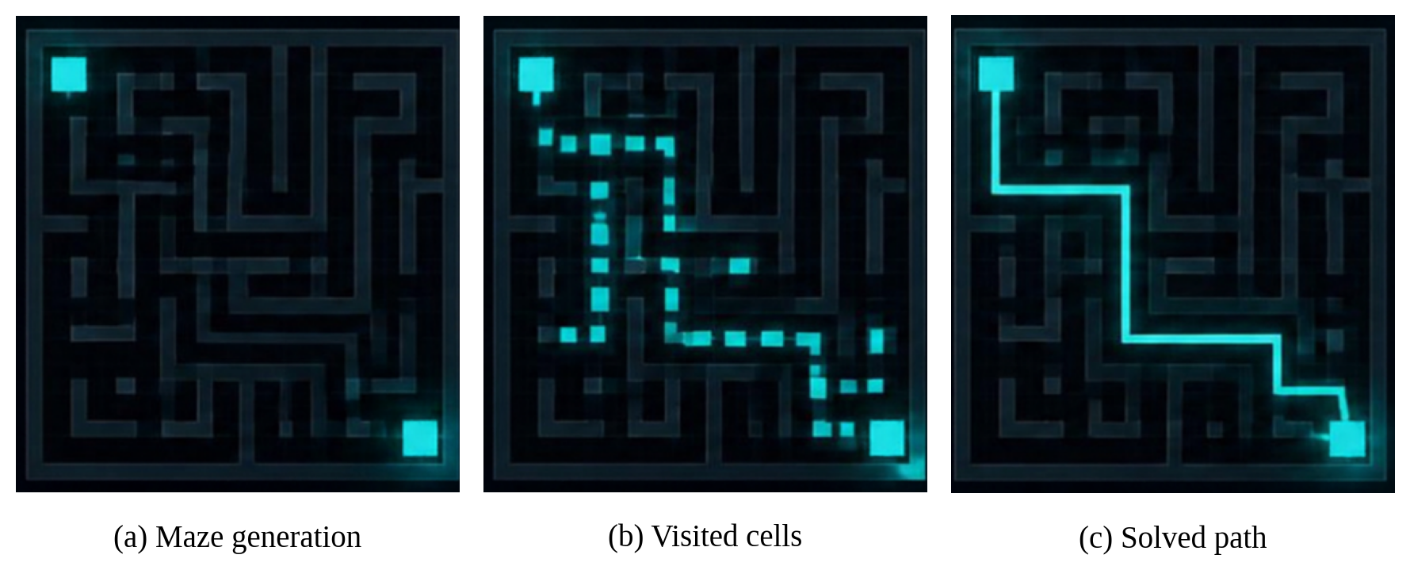
Figure 5.1 Visual output of the maze solver: (a) generated maze, (b) visited cells, (c) solved path
These views achieve the primary educational objective of the project: the learner sees, cell by cell, how much of the maze an algorithm needed to look at before it found the exit, and can compare that with the length of the final path.

5.2.2 Algorithm comparison
Table 5.2 reports the path length and the number of nodes visited by the four reference algorithms on the sample maze, as recorded in the “Algorithm Comparison” output panel of the application, together with their theoretical guarantees. Figure 5.2 plots the number of nodes visited.
Table 5.2 Performance of the reference algorithms on the sample maze
Metric | BFS | DFS | A* | Dijkstra
Path length | 21 | 24 | 22 | 22
Nodes visited | 124 | 312 | 76 | 102
Uses heuristic | No | No | Yes (Manhattan) | No
Optimal in theory | Yes | No | Yes | Yes

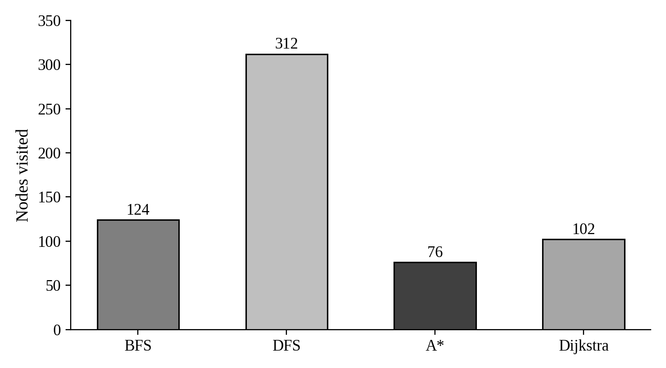
Figure 5.2 Nodes visited by each reference algorithm on the sample maze
Several observations follow from the comparison:
- DFS explored the most cells (312) and produced the longest path (24). This confirms that depth-first exploration can wander deep into wrong branches, and that the path it returns is not guaranteed to be the shortest.
- Informed search examined the fewest cells (76). A* combines the accumulated cost with the Manhattan estimate, so it avoids expanding cells that lead away from the exit, achieving about 39% fewer nodes than BFS (124) and about 25% fewer than Dijkstra (102).
- Dijkstra (102) and BFS (124) expand cells in order of distance from the start without any guidance toward the goal, so they visit more cells than A* to reach a path of similar length. On a unit-cost grid Dijkstra's algorithm behaves like BFS with a priority queue.
- The path lengths of the three optimal algorithms lie within one step of each other (21 to 22), whereas DFS returned a path of 24 moves, about 9 to 14% longer.

5.2.3 Behaviour of the local-search algorithms
The central objective of the project was to study Hill Climbing and Simulated Annealing on the same maze. The results of the application can be summarised as follows.
Hill Climbing. In corridors along which the Manhattan distance falls steadily, Hill Climbing moves almost straight to the exit and visits very few cells, which makes it by far the cheapest algorithm in terms of exploration and memory. When it enters a pocket whose only way out involves an increase in h, it stops there. The visualiser marks the stopping point, which allows the student to see the exact cell and the surrounding walls that caused the failure.
Simulated Annealing. Because it accepts occasional worsening moves while the temperature is high, Simulated Annealing is able to leave such pockets. The animation shows the walker wandering in the early phase, sometimes moving away from the exit, and then settling as the temperature falls and the acceptance probability of worsening moves drops (Table 3.2). As the project's results note, this lets the system handle local optima without getting trapped. The price is a longer and less direct route and a run-to-run variability that Hill Climbing does not have.
Table 5.3 Observed behaviour of the two local-search algorithms
Criterion | Hill Climbing | Simulated Annealing
Exploration | Minimal; follows the heuristic gradient | Broad in the early phase, narrowing as T falls
Result on maze with dead ends | May stop at a local optimum | Escapes local optima and reaches the exit
Route taken | Direct when successful | Longer, with detours
Repeatability | Identical on every run | Varies between runs
Tuning effort | None | Temperature and cooling rate must be chosen
Best suited to | Fast solution of easy landscapes | Rugged landscapes with many local optima

5.2.4 Summary of findings
The execution observations confirm stable performance across runs, and the key metrics were captured for each algorithm. In summary:
- The path-finding behaviour of the system shows correct and efficient routes: every path drawn is a valid sequence of adjacent open cells from the start to the exit.
- The heuristic-guided algorithms, A* in particular, substantially reduce the number of cells explored compared with uninformed search.
- The local-search algorithms complement the systematic algorithms: Hill Climbing shows the value and the danger of greedy choice, and Simulated Annealing shows how controlled randomness overcomes local optima.
- Running all algorithms on the same maze, with the metrics collected in a single place, achieves the goal of side-by-side comparison identified in the research gap.

5.2.5 Educational value
Judged against the engagement principles reported in the literature (Hundhausen et al., 2002; Naps et al., 2002), the system supports active learning: students can predict whether an algorithm will reach the exit, change the maze or parameters, re-run, and examine the metrics. Concepts that are otherwise abstract, such as local optima, the Metropolis criterion and the effect of temperature, become directly observable. A formal classroom study of learning outcomes was not part of this project and is proposed as future work.

CHAPTER 6

CONCLUSION AND FUTURE WORK

6.1 CONCLUSION
This project set out to make the abstract theory of AI search observable. It produced an interactive maze-solving environment in Python in which two local-search algorithms, Hill Climbing and Simulated Annealing, are implemented on a common state representation and guided by the Manhattan-distance heuristic. The modular architecture, consisting of a User Interface, Maze Manager, Algorithm Engine, Visualizer Engine and Results Analyzer, keeps drawing, maze creation, search and measurement independent, so that the tool is extendable and its results are trustworthy.
The results show that the four objectives were met. Search behaviour is visualised in real time; two local-search algorithms are implemented; their behaviour can be compared on the same maze, together with reference results for BFS, DFS, Dijkstra and A*; and the whole is packaged as an educational maze game. The comparison confirms well-known theoretical properties: informed search (A*) explores far fewer cells than uninformed search, DFS is neither efficient nor optimal, Hill Climbing is fast but liable to be trapped by local optima, and Simulated Annealing trades directness and determinism for the ability to escape them.
The project thus addresses the research gap identified at the outset: instead of being taught in isolation, the algorithms can be watched side by side on identical input in an interactive, maze-focused setting.

6.2 LIMITATIONS
- Hill Climbing and Simulated Annealing give no guarantee of finding the exit or of finding the shortest path.
- The Manhattan heuristic ignores walls, so in highly convoluted mazes it can mislead the local-search algorithms.
- The mazes considered are small, static, two-dimensional, unit-cost grids.
- The educational effectiveness of the tool has not yet been measured through a controlled study with students.

6.3 FUTURE WORK
- More algorithms. Add random-restart, stochastic and first-choice Hill Climbing, Tabu Search, Beam Search and Genetic Algorithms to the extendable Algorithm Engine.
- Better heuristics. Investigate heuristics that account for walls, such as true shortest-path distance computed on the maze graph, and study their effect on local optima.
- Richer environments. Introduce weighted terrain, larger mazes, diagonal movement, moving obstacles and multiple goals.
- Adaptive Simulated Annealing. Implement alternative cooling schedules (linear, logarithmic, adaptive) and allow the student to plot the temperature and acceptance rate during a run.
- Side-by-side mode. Run two or more algorithms simultaneously in separate panes of the same window, with synchronised step counters.
- Statistical evaluation. Automate batch experiments over many random mazes and report means and variances for path length, nodes visited, time and memory.
- Learning-based agents. Add reinforcement-learning agents (for example Q-learning) to contrast learned policies with hand-designed search.
- Deployment and user study. Package the tool for the web or as a desktop installer and evaluate learning gains with a class of students.

CHAPTER 7

REFERENCES

Buck, J. (2015) Mazes for Programmers: Code Your Own Twisty Little Passages. Raleigh, NC: The Pragmatic Bookshelf.
Černý, V. (1985) ‘Thermodynamical approach to the traveling salesman problem: an efficient simulation algorithm’, Journal of Optimization Theory and Applications, Vol.45, No.1, pp.41-51.
Cormen, T.H., Leiserson, C.E., Rivest, R.L. and Stein, C. (2022) Introduction to Algorithms, 4th edn. Cambridge, MA: MIT Press.
Dechter, R. and Pearl, J. (1985) ‘Generalized best-first search strategies and the optimality of A*’, Journal of the ACM, Vol.32, No.3, pp.505-536.
Dijkstra, E.W. (1959) ‘A note on two problems in connexion with graphs’, Numerische Mathematik, Vol.1, No.1, pp.269-271.
Hart, P.E., Nilsson, N.J. and Raphael, B. (1968) ‘A formal basis for the heuristic determination of minimum cost paths’, IEEE Transactions on Systems Science and Cybernetics, Vol.4, No.2, pp.100-107.
Hundhausen, C.D., Douglas, S.A. and Stasko, J.T. (2002) ‘A meta-study of algorithm visualization effectiveness’, Journal of Visual Languages & Computing, Vol.13, No.3, pp.259-290.
Johnson, D.S., Aragon, C.R., McGeoch, L.A. and Schevon, C. (1989) ‘Optimization by simulated annealing: an experimental evaluation; part I, graph partitioning’, Operations Research, Vol.37, No.6, pp.865-892.
Kirkpatrick, S., Gelatt, C.D. and Vecchi, M.P. (1983) ‘Optimization by simulated annealing’, Science, Vol.220, No.4598, pp.671-680.
Korf, R.E. (1985) ‘Depth-first iterative-deepening: an optimal admissible tree search’, Artificial Intelligence, Vol.27, No.1, pp.97-109.
Metropolis, N., Rosenbluth, A.W., Rosenbluth, M.N., Teller, A.H. and Teller, E. (1953) ‘Equation of state calculations by fast computing machines’, The Journal of Chemical Physics, Vol.21, No.6, pp.1087-1092.
Naps, T.L., Rößling, G., Almstrum, V., Dann, W., Fleischer, R., Hundhausen, C., Korhonen, A., Malmi, L., McNally, M., Rodger, S. and Velázquez-Iturbide, J.Á. (2002) ‘Exploring the role of visualization and engagement in computer science education’, ACM SIGCSE Bulletin, Vol.35, No.2, pp.131-152.
Pearl, J. (1984) Heuristics: Intelligent Search Strategies for Computer Problem Solving. Reading, MA: Addison-Wesley.
Russell, S. and Norvig, P. (2021) Artificial Intelligence: A Modern Approach, 4th edn. Hoboken, NJ: Pearson.
Shaffer, C.A., Cooper, M.L., Alon, A.J.D., Akbar, M., Stewart, M., Ponce, S. and Edwards, S.H. (2010) ‘Algorithm visualization: the state of the field’, ACM Transactions on Computing Education, Vol.10, No.3, Article 9.

